Databases
Laboratory work 1
Suleimen Zhaniya
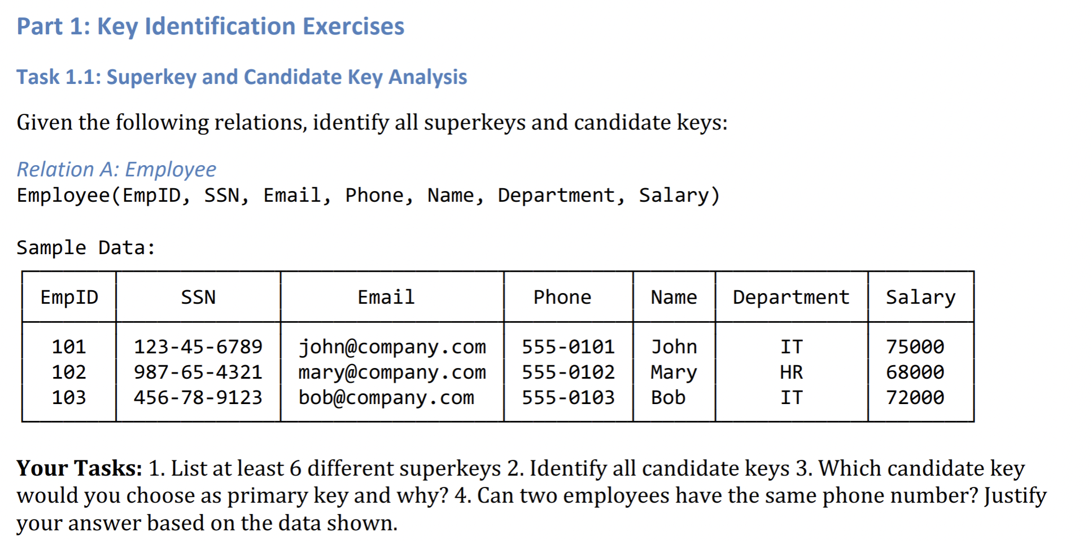
Answers:
1)Superkeys:
1.{EmpID} 2.{SSN} 3.{Email} 4.{Phone} 5.{EmpID} 6.{Email,Phone}

2)Candidate keys:
1.{EmpID} 2.{SSN} 3.{Email} 4.{Phone}

3) Which candidate key would you choose as primary key and
why?

{EmpID}- can be choosen as primary key
Reasons:
It very short and simple, it isn’t confidentshial information, and it can’t change

4) Can two employees have the same phone number? Justify your
answer based on the data shown.

No, two employees can’t have the same phone number (all phone number are unique)
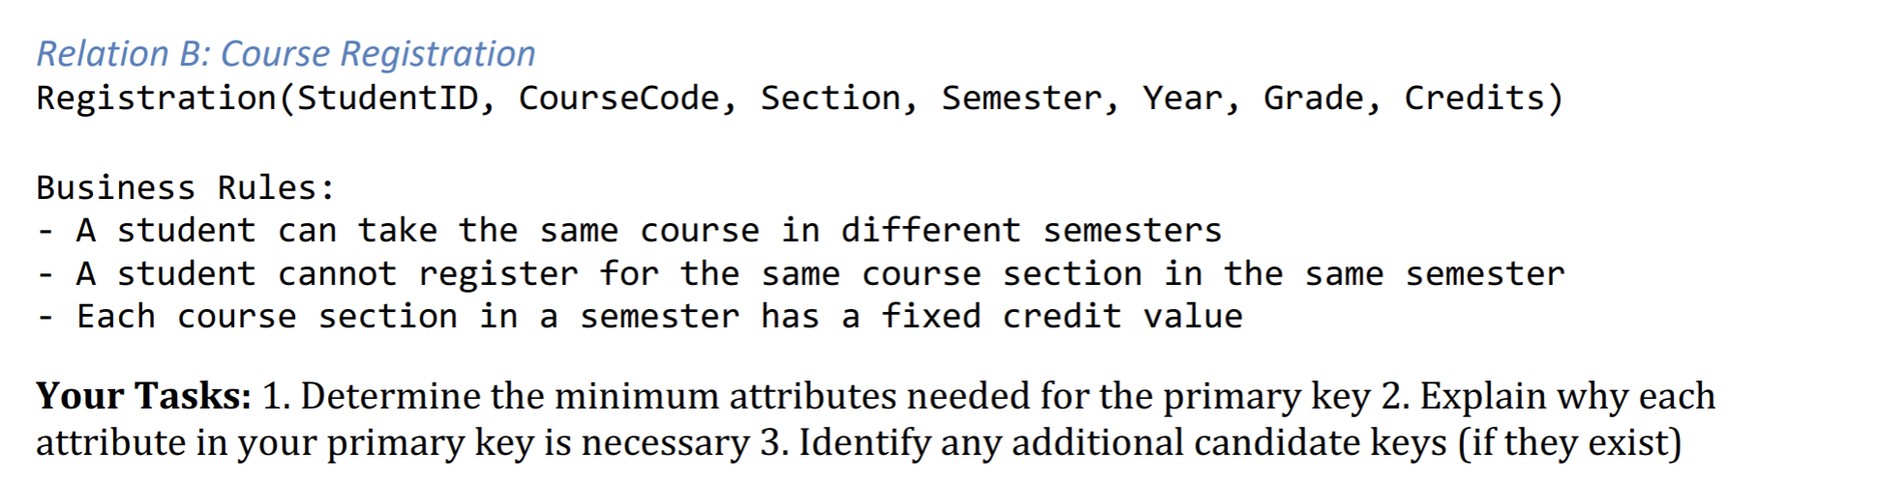
1) Primary key: {StudentID, CourseCode, Section, Semester, Year}

2) StudentID – student can take the same course in same course
CourseCode - student can take the same course in different course
Section – one course can have been same sections
Semester – student can choose same course in different semester
Year - in one year we have same semester

3) Additional Candidate Key = (StudentID, CourseCode, Section, Semester, Year)

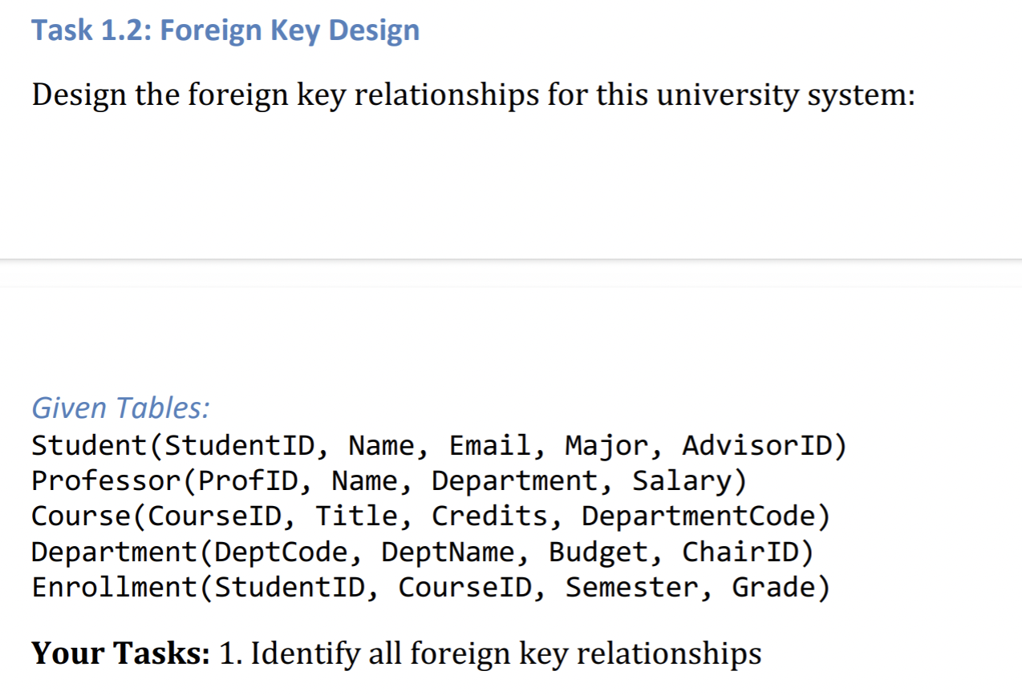
Course.DepartmentCode -> Department.DeptCode

Enrollment.StudentID -> Student.StudentID

Enrollment.CourseID -> Course.CourseID

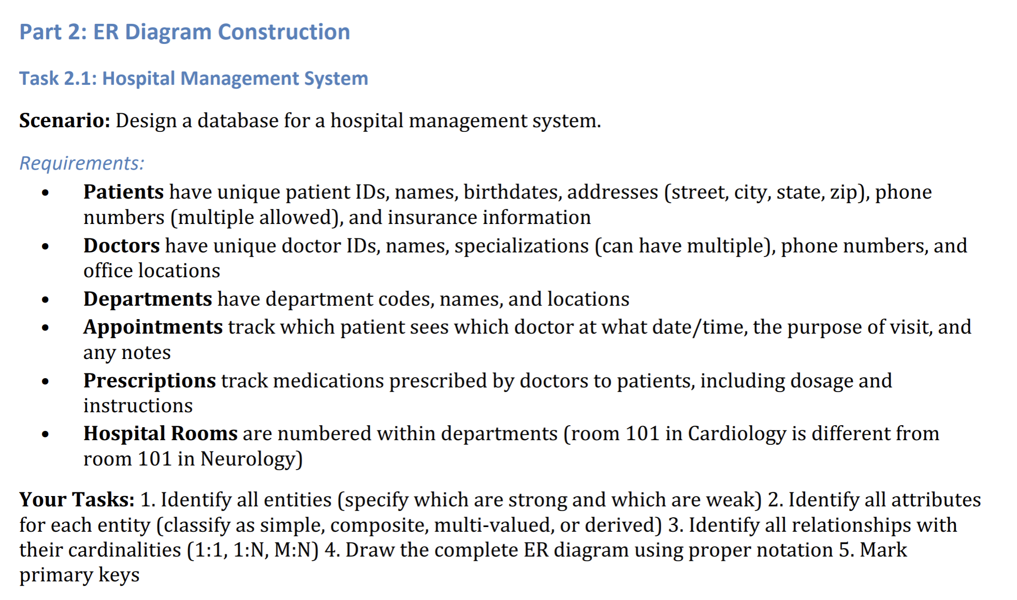
1)
Strong – Patients, Doctors, Departments, Appointments, Prescriptions
Weak – Hospital Rooms

2) Patients : Doctors:

- PatientID – Primary key, simple - DoctorID – Primary key, simple

- Name – simple - Name – simple

- Birthdate – simple - Specialization – multi-valued

- Address – composite: (street,city,state,zip) - PhoneNumber – simple

- PhoneNumber – multi-valued - OffLocation – simple

- Insurance – simple

Departments: Appointments:

-DepartmentCode – Primary key -AppID – Primary key

-Name – simple -DoctorName – Simple

-Locations - simple – - Date - Simple
-
-Purpose – simple

-Notes – simple

Prescriptions: Hospital Rooms:

-PrescriptionsID – Primary key - RoomNumber - partial key

-Medications – simple - DepartmantCode – Foreign key

- Patients – simple

- Dosage – simple

- Instructions – simple

3) Relationships with cardinalities:

1 : 1 – we dont have this type relations

1 : N – Patient->Appointment, Doctor->Appointment, Doctor-> Prescriptions,

Patient-> Prescriptions, Department->HospitalRooms

Patient N:M Doctor (with Appointment)

4) 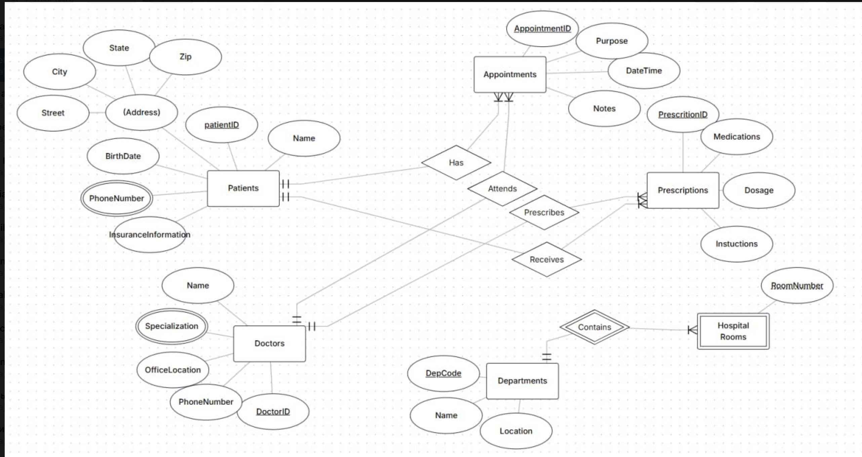

5) Pk are marked with underline

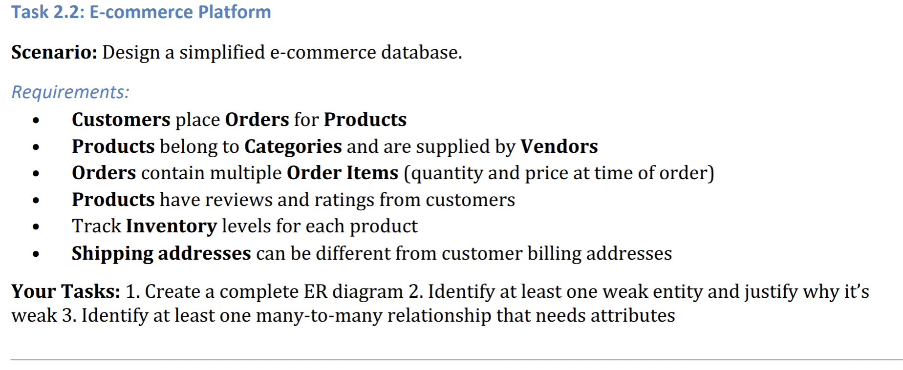
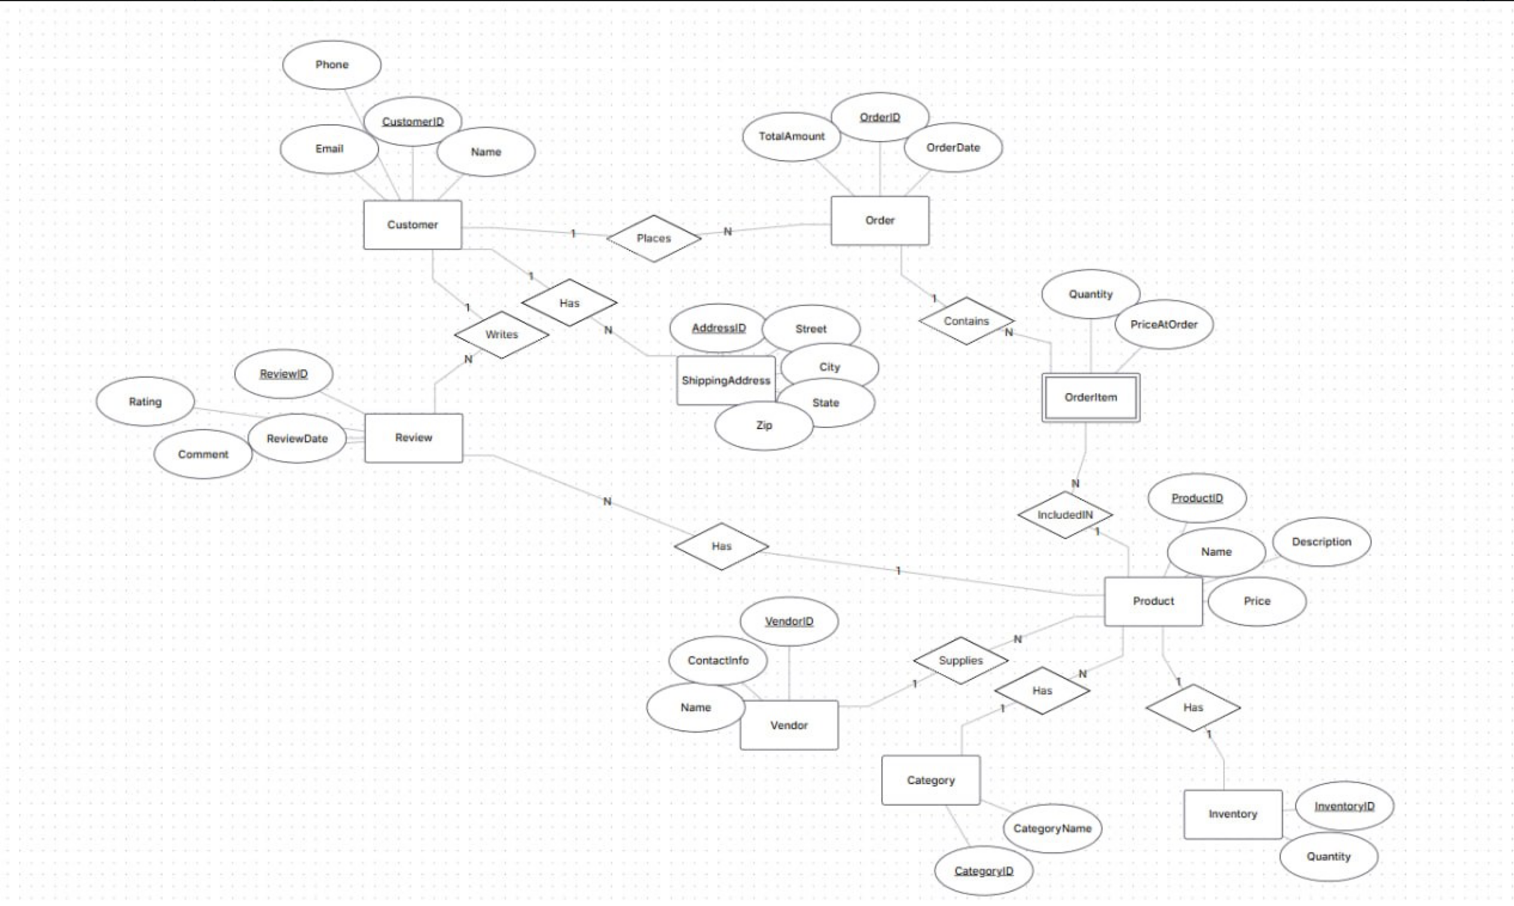
2) OrderItem is a weak entity because it cannot exist without an Order and a Product.

3) Order and Product have a many-to-many relationship through OrderItem. The
relationship has attributes Quantity and PriceAtOrder.

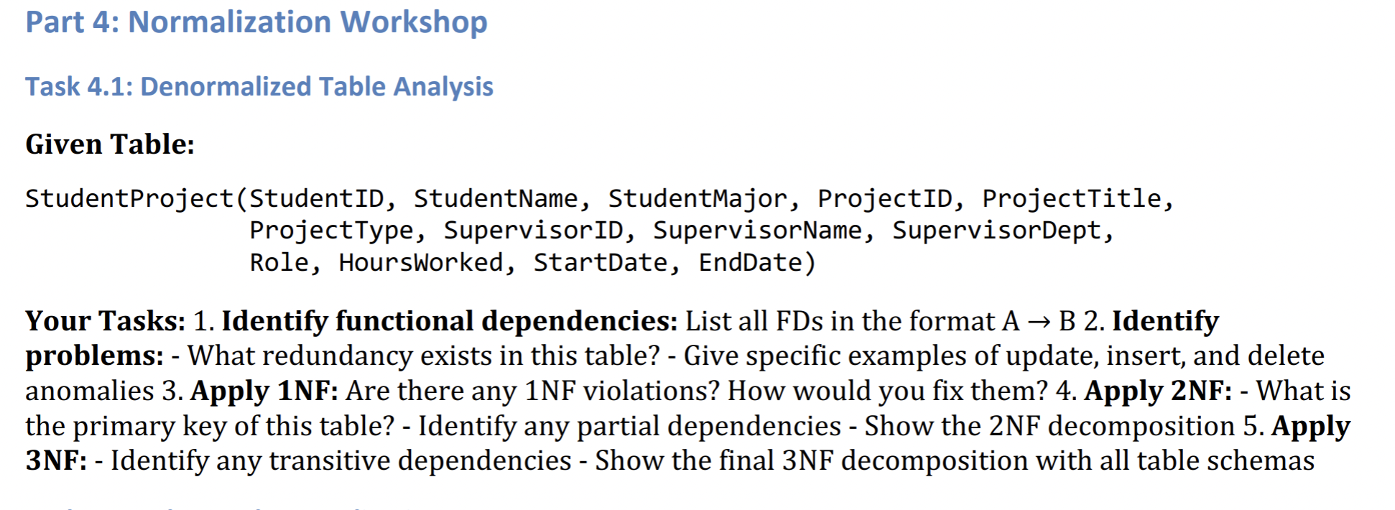
1)
StudentID -> StudentName,StudentMajor

ProjectID -> ProjectTitle, ProjectType

SupervisorID -> SupervisorName, SupervisorDept

StudentProject (StudentID, ProjectID) -> Role, HoursWorked, StartDate, EndDate

2) Redundancy:
- Name and major of student are repeated for each project

- The name and department of the supervisor are repeated for each student working on
the project.

Anomalies:

Update: If the head’s department changes, all lines where it appears need to be
updated.

Insert: You cannot add a new student without a project, as the ProjectID is
mandatory.

Delete: If you delete the last entry about the project, you will lose information
about the project itself and its leader.

3) The table is already in 1NF. (all values are atomic)

4) Primary Key: (StudentID, ProjectID)

Partial dependences:
StudentID -> StudentName,StudentMajor

ProjectID -> ProjectTitle, ProjectType

SupervisorID -> SupervisorName, SupervisorDept

2nf:

Student (StudentID, StudentName, StudentMajor)

Project (ProjectID, ProjectTitle, ProjectType, SupervisorID)

Supervisor (SupervisorID, SupervisorName, SupervisorDept)

StudentProject (StudentID, ProjectID, Role, HoursWorked, StartDate, EndDate)

5) transitive depences: Project: SupervisorID-> SupervisorName, SupervisorDept (with SupervisorID)

3nf:
Student (StudentID, StudentName, StudentMajor)

Project (ProjectID, ProjectTitle, ProjectType, SupervisorID)

Supervisor (SupervisorID, SupervisorName, SupervisorDept)

StudentProject (StudentID, ProjectID, Role, HoursWorked, StartDate, EndDate)

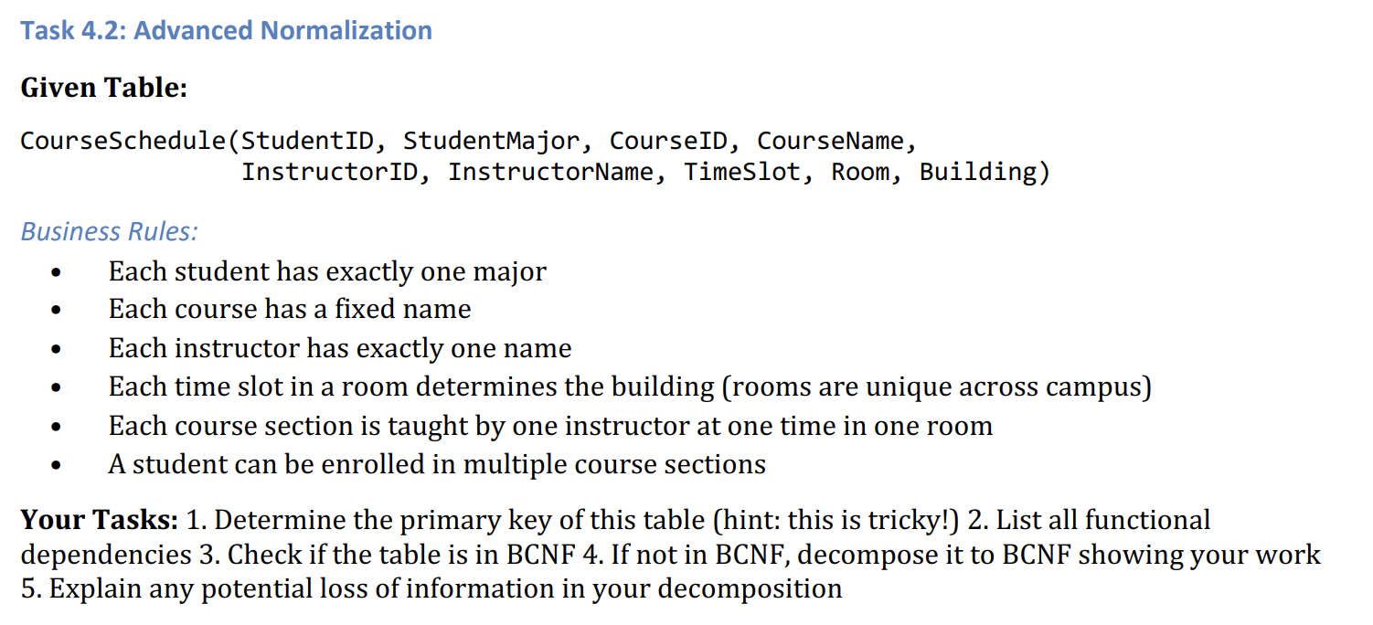
1) Primary Key: (StudentID, CourseID, TimeSlot, Room)

2) from Business Rules:

StudentID -> StudentMajor CourseID -> CourseName

InstuctorID->InstructorName Room -> Building

(CourseID, TimeSlot, Room) -> InstructorID

(StudentID, CourseID, TimeSlot, Room) -> all other attributes (this is the key).

3) BCNF — every determinant must be a superkey

StudentID → StudentMajor (StudentID is not a key).

CourseID → CourseName (CourseID is not a key).

InstructorID → InstructorName (InstructorID is not a key).

Room → Building (Room is not a key ).

Table is not BCNF.

4) Decompose to BCNF

Students(StudentID, StudentMajor)

Courses(CourseID, CourseName)

Instructors(InstructorID, InstructorName)

Rooms(Room, Building)

CourseSections(CourseID, TimeSlot, Room, InstructorID)

Enrollments(StudentID, CourseID, TimeSlot, Room)

5)There is no data loss, but there is a need to join tables via JOIN to obtain the
original information.

For example, to find out a student’s schedule, you need to join Enrollments with
CourseSections, and then with Courses, Instructors, and Rooms.

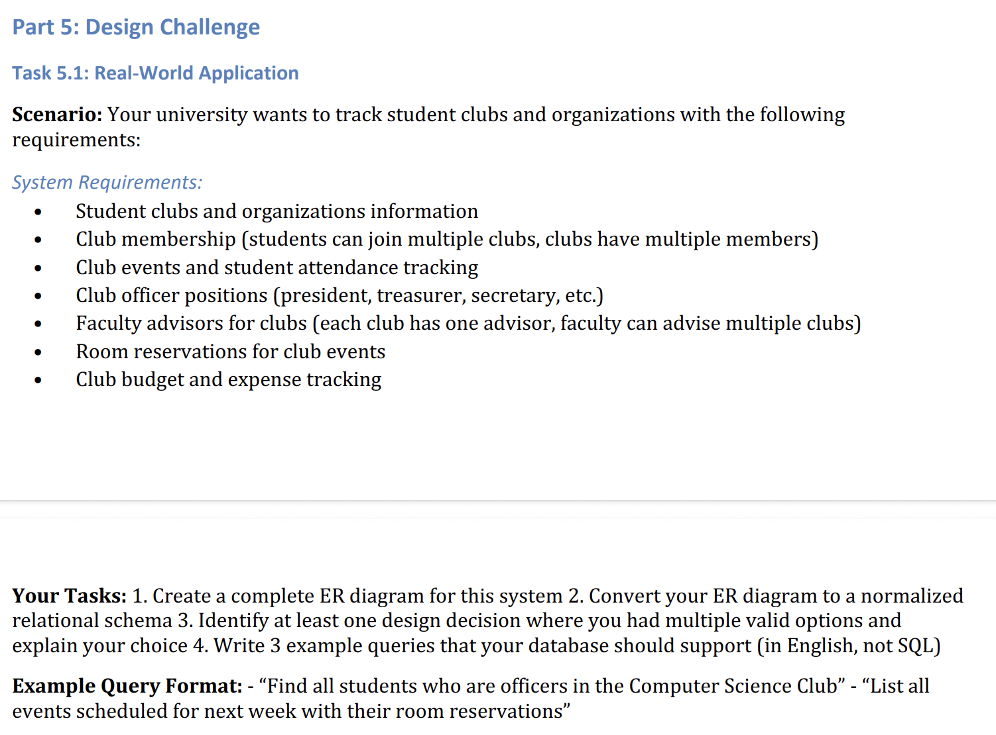
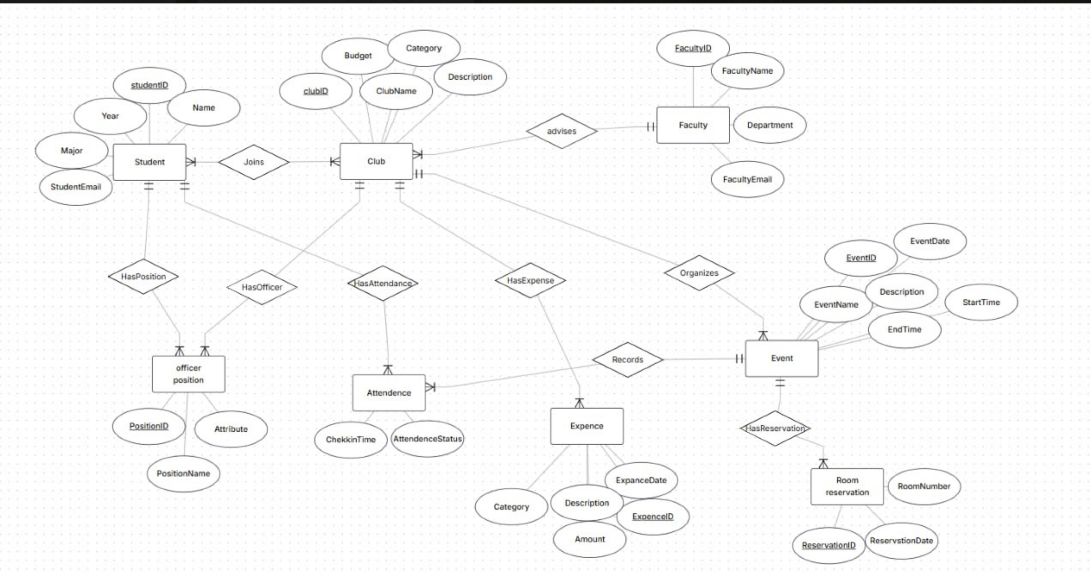

2)Student(StudentID PK, Name, Year, Major, StudentEmail)

Faculty(FacultyID PK, FacultyName, Department, FacultyEmail)

Club(ClubID PK, ClubName, Description, Category, Budget, FacultyID
FK)

OfficerPosition(PositionID PK, PositionName, Attribute, ClubID FK,
StudentID FK)

Event(EventID PK, EventName, EventDate, Description, StartTime,
EndTime, ClubID FK)

Attendance(StudentID PK/FK, EventID PK/FK, CheckInTime,
AttendanceStatus)

Expense(ExpenseID PK, ExpenseDate, Category, Description, Amount, ClubID
FK)

RoomReservation(ReservationID PK, ReservationDate, EventID FK,
RoomNumber FK)

3) Design decision:Room booking could be done in two ways: store RoomNumber and ReservationDate as attributes of Event, or make a separate RoomReservation entity.
I chose the separate entity. Inside Event it would mean one event always has exactly one room, and a booking can't exist without a confirmed event. Separating it lets rooms be shared campus resources, keeps booking history, and avoids NULLs for online or outdoor events.

4) 1.Find all clubs and their current budget balance (budget minus total expenses).
2.List all faculty advisors who advise more than one club.
3.List all events happening next week along with their room reservations.

